CARRY THE CLOUDS AWAY

NEW ADELPHI EXHIBITION GALLERY

17TH AUGUST – 18TH DECEMBER 2026

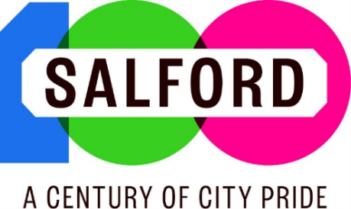
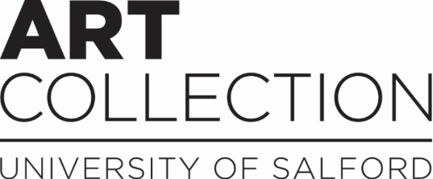

Carry the Clouds Away
17th August – 18th December
New Adelphi Exhibition Gallery

Carry the Clouds Away brings together contemporary art, community projects, and works from the University Art Collection to explore the varied ways in which we find inspiration, connection, and solace in places of nature.

Our own Peel Park marks its 180th anniversary this autumn and is the inspiration for several artists. Laura Daly’s The Storm Cone reimagines the site of the former bandstand and its rich history through an augmented reality app; whilst Liam Ratcliffe’s photography captures the ever-changing seasons and skylines over the past year. Alumna Lizzie King’s postcards celebrate the park as a place of rest and escape - and once even a popular holiday destination!

Several projects highlight relationships between people, place and sense of community. Hayley Suviste’s work with local charity Salford Loaves and Fishes responds to the River Irwell through printmaking, writing and audio-visual work; whilst Adelina Court’s illustrations capture the development of a new community garden in Eccles. Pottery inspired by natural forms is generously loaned from START, a local mental health charity that uses creativity to improve lives.

Further works reflect on personal connections with nature. Graduate Jack Jameson considers the natural world through queer ecology; and current BA Photography student Alyssa Fort reveals the world in intimate detail through microscopic photography. The exhibition also features a selection of works from the University Art Collection, celebrating the enduring joy and inspiration that nature offers.

We welcome you to spend time in the gallery to rest and unwind and consider how connecting with places of nature might support your own inspiration and wellbeing. If you’d like to find out more, there are links below and on our gallery labels to some of our highlighted projects and wider programmes.

Connect further:


Peel Park 180: This exhibition was created to coincide with the 180th anniversary of Peel Park in Autumn 2026, drawing on the parks’ themes of heritage, biodiversity and wellbeing. Follow Peel Park online, including the Friends of Peel Park @peelparksalford to find out more about upcoming events and activities.


OFFSHOOT: The exhibition also complements OFFSHOOT, a collaboration between the University of Salford Art Collection, RHS Garden Bridgewater and Open Eye Gallery, Liverpool. Explore commissioned artworks on-site at the RHS until February 2027; alongside a new exhibition at Salford Museum & Art Gallery from mid-October 2026. Visit offshoot.salford.ac.uk to find out more. OFFSHOOT is generously supported using public funding by the National Lottery through Arts Council England.

Art Collection: The University of Salford Art Collection hosts exhibitions, events, residencies and more throughout the year, including many on themes of nature & environment. Find out more at our website below.



Sustainability at Salford: The University has a vibrant and active sustainability community, including shared growing spaces as well as a programme of events, talks and activities. Find out more on our info screen, and at @uos_sustain. Don’t miss the Go Green Festival in March and October each year.


Salford 100: 2026 also marks one hundred years of city status for Salford, with events, activities and celebrations throughout the year. Find out more at salford100.org.uk.

Credits:
Thank you to Ann Chan from Salford Loaves and Fishes Community, whose poem (on display in the gallery) inspired our exhibition title. Thank you to artist Lizzie King for exhibition graphic design
Contact us:

Artcollection.salford.ac.uk

Artcollection@salford.ac.uk

@uos_artcollection

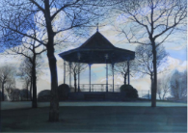
Michael J Goodger
Peel Park Bandstand (1970)
Watercolour and gouache

Michael Goodger (b.1933) is best known as a filmmaker and photographer, though he had early training as a painter. He joined the University of Salford as a lecturer in the late 1960s, around the time the institution gained University status in 1967.

Goodger’s work captured the city at a time of dramatic transformation and redevelopment. His acclaimed film trilogy The Changing Face of Salford (1971) recorded housing and social conditions at the time and had a widespread impact including a screening at the House of Commons.

Peel Park Bandstand, a rare example of his painting practice, continues this record of a city in transition. The park is celebrated as one of the first public parks in the UK, opened in 1846. The addition of the bandstand in 1902 provided a vibrant meeting place for local workers and families, who could enjoy free music each week. Like many Victorian bandstands however it declined in popularity through the decades and was eventually demolished in the late 1960s. In this painting it stands empty – perhaps a moment of calm reflection on its past, or perhaps a sign of change to come.

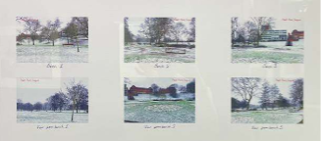
Lizzie King
Rooted (2021)
Giclee print

Rooted is a collection of postcards depicting three benches in Peel Park, and the views from these benches. It was originally produced as part of a body of work for Rediscovering Salford (2021), a citywide partnership project which explored and celebrated the city’s green spaces.

During her research, Lizzie discovered a wealth of Peel Park postcards dating to the early 1900s. Personal inscriptions on the reverse revealed the park as a popular holiday destination, as well as somewhere for local families to enjoy. Bringing back the tradition of the ‘Peel Park postcard’, the artist invites visitors to share their own memories with others. As one of the first public parks in the UK, Lizzie notes “Peel Park is a place for the people of Salford to belong, and I hope the artwork can help people think about how they relate to the park.” In our fast-paced lifestyles, they serve as a reminder to slow down, rest, recover and reflect.

Lizzie King is an artist from Salford who works with digital and analogue forms of photography, printmaking and sound to explore the “narratives of our human centred universe”. She graduated from the University of Salford BA Visual Art in 2014 and took part in the Art Collections’ graduate Scholarship scheme. She has exhibited in the UK and internationally, and returned to the University in 2024 to complete an MA in Contemporary Fine Art.

Lizzie King
Rooted (2021)
Giclee print

Postcards:
Peel Park turns 180 in Autumn 2026. You are welcome to write or draw your own thoughts, memories and stories of Peel Park and local green spaces on the adjacent postcard wall or take a card as a memento.

Originally commissioned as part of Rediscovering Salford, a collaboration between the University of Salford Art Collection, Salford Museum & Art Gallery, and Salford Culture and Place Partnership. It was generously supported using public funding by the National Lottery through Arts Council England, and the City Mayor’s Suprema Lex 2020 commissions.

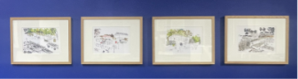
Adelina Court
Cleavley Community
Forest Garden (2019)
Digital print from original watercolour illustration

(left to right: Raised Beds and Blackbird, Bird’s Eye View of the Garden, The Community Café, The Farmers Market)

Using vibrant colours and expressive brushstrokes, Court breathes life into the planning of Cleavley Community Forest Garden, which now stands proudly in place of what was once an overgrown and disused plot in Eccles. These illustrations were created as part of a collaboration between Incredible Education CIC, the University of Salford, and the community in Eccles. Through guided walks in the plot and conversations with volunteers and community members, Adelina developed concepts for the garden that considered the community’s social, educational, and practical needs. This method, called ‘graphic facilitation’, promotes an open discussion, helping create a blueprint for the garden that grows and changes, reacting to feedback from those who will go on to use it.

Adelina Court is an illustrator and animation director. Her work is mostly reportage-based and focuses on visualising projects with and for communities. Adelina teaches on BA Costume Design and BA Film, TV, and Stage design at The University of Salford.

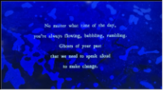
Hayley Suviste
The River Has Many Lives (2026)
Audio-visual artwork (20mins);
and cyanotypes (see display case)

This project is an exploration of the past, present, and future of the River Irwell, produced by Hayley Suviste in collaboration with participants from local charity Salford Loaves and Fishes. Following the waterway from Peel Park to Kersal Wetlands, this project presents a glimpse of the conversations, discoveries and creative processes that evolved through the workshops led by guest facilitators Fiona Brehony (poetry and zine-making), Vicky Clarke (field recording and underwater listening), Lizzie King (cyanotype and photography), and Morag Rose (guided walk).

Suviste’s approach to exploring this ecosystem has fostered inclusive and holistic ways in both connecting with nature and with others.
Underlining the project are explorations of wellbeing, biodiversity and climate change, particularly in an urban context. The work
encourages us to pause, listen closely, and consider the many different lives and stories of the river. The River Has Many Lives is a continuation of Suviste’s previous work From the River’s Mouth (2025) originally commissioned by University of Salford Art Collection in collaboration with the University’s Acoustics Laboratories, for Sounds From The Other City Festival.

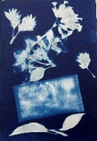
Hayley Suviste
The River Has Many Lives (2026)
Cyanotypes and ink on paper;
Audio visual work (see large screen)

These cyanotype prints and hand-written poems accompany the audiovisual work on the large screen in the gallery. They were produced during workshops with participants from Salford Loaves and Fishes, a local charity which supports homeless, isolated or vulnerable members of the community. The prints and poems tell stories of, and to, the local River Irwell.

With thanks to the participants and co-creators:
Aki, Alan Lai, Ann Chan, Ann Li, Basheer, Florin-Marian Mehtupciu, Karl Mather, Lee, Neil Baines, Selina Lo, Silvia P.B. Mendes, Stuart Watson, Teresa Leung and Vilson Beveilli Mendes. Special thanks to the staff at Salford Loaves and Fishes – Hannah, Helen, Janice, Jennifer, Joe and Jodie – whose generosity and support made this project possible.

Supported by: North West Consortium Doctoral Training Partnership (NWCDTP), Salford Loaves and Fishes, University of Salford Art Collection
and Acoustic Laboratories.


START Inspiring Minds
Jug (2026) & Bowl (2026)
by Helen Beech; Sea Urchin (2026),
Plankton (2026), Grapes (2026) by
students at START Inspiring Minds
Ceramics

START is a Salford based mental health charity that uses creativity, connection and recovery interventions to help improve people’s lives.

These works were created at START’s ceramic workshops, part of the Inspiring Minds programme, which encourages practical skills, improved self-confidence, and mental health recovery. Over 12 months members can progress from basic skills such as creating coil, pinch, and slab pots, to more advanced skills such as throwing and glazing. These ceramics demonstrate the technical skills developed through months of workshops, with motifs and designs inspired by nature such as a sea urchin, shell imprints on the bowl’s interior and a fern leaf on the jug.

START has been delivering vital services in Salford for over 30 years. Find out more about their many programmes at the QR code above or visiting startinspiringminds.org.uk and @startinsalfordart


Projects showcase: Sustainability at the University of Salford (1m 28s)

The Sustainability Team at Salford lead the University’s mission to be Net Zero Carbon by 2038, with inspiring real-world ambitions and impact across energy and water use, climate resilience, greener procurement and more. They maintain many green spaces and activities on campus and have engagement opportunities throughout the year, from Plastic Free July, Green Impact and the Hedgehog Friendly Campus initiatives to the Go Green festival which takes place in Spring and Autumn. Follow @uos_sustain or scan the QR code to get involved.

Projects Showcase: Fowziyah Adam
Peel Park Graphic Design Competition (1m 44s)
To celebrate Peel Park's 180th anniversary in 2026, the University of Salford BA (Hons) Graphic Design course ran a live brief for students to create a new brand identity. Images here are from competition winner Fowziyah Adam, who took inspiration from the park’s vast history and its importance to local communities. “The project really stretched me as a designer, and I feel so lucky that my work will be part of the park’s history”. Follow @salfordgraphics to find out more about the course.

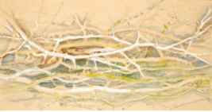
Daniel Gleeson
Twigs II (1971)
Watercolour and pencil on paper

Twigs II was one of the earliest acquisitions into the
University of Salford Art Collection, which began in the late 1960s. A number of works during this formative period have limited documentation, and little is currently known about the artist beyond his roots in Manchester (b.1938) and interest in recording the natural world.

In this work the artist perhaps invites a closer appreciation of an everyday subject matter, using fine lines and gentle application of highlight, colour and shadow.

We are continuing to research the artist and if you have any information about Gleeson or his practice, we would be delighted to hear from you.

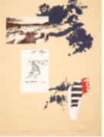
Adrian Henri
Souvenir of Normandy II (1981)
Screen-print

Artist Adrian Henri was a frequent visitor to Normandy in Northern France, often travelling with friends, fellow artists and poets. This screen print is one of a series bringing together notes and sketches with natural imagery.

A delicate sketch, perhaps of a friend; a holiday postcard; shadows of leaves or natural forms, and an unreadable piece of a magazine or poster. Together these items begin to tell a story of a particular time and place – a visual diary of personal memories, left open to interpretation.

Adrian Henri (1932 – 2000) was a British poet and artist born in the Wirral. He is best known as founder of the ‘poetry-rock’ group the Liverpool Scene. These screenprints were produced at the Manchester Print Workshop, which was based at the University in the 1970s-80s.

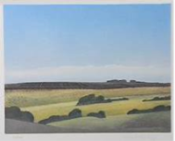
Michael Fairclough
Predanach Moor, Spring Ploughing (1970)
Colour Aquatint

Michael Fairclough is a British painter and printmaker, known for his atmospheric works exploring sky, sun, sea, land and coast across the UK. He is often inspired by the changing qualities of light and atmosphere - from sunset to twilight and across the changing seasons. This work captures Predanach Moor, also known as the Predannack Downs, on the south coast of Cornwall, a natural area designated as Site of Special Scientific Interest.

Fairclough’s deep understanding of the landscape has been recognised by a wide range of commissions and purchases, from the National Trust to the Meteorological Office.

Michael Fairclough (b. 1940, Lancashire) is a painter and printmaker who also taught at the Belfast School of Art and West Surrey College of Art. He has exhibited widely in Britain and abroad with many of his works held public, corporate, and private collections. He is a fellow of the Royal Society of Painter-Etchers.

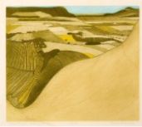
John Brunsdon
View Towards Beachy Head
(circa 1970s)
Etching

Brunsdon’s etching uses hand colouring combined with intaglio printmaking techniques to capture the tumbling hills and patchwork farms of Beachy Head in East Sussex.

Dividing the landscape are plough lines, fences, boundaries and crops – a vast expanse of land marked out for agricultural use. The print could be read as both at a peaceful reflection on the landscape as well as a quiet contemplation on the ways in which it is shaped by human activity.

John Brunsdon (1933-2014) was a printmaker and painter and has works held in collections including Tate, the Scottish Museum of Modern Art and the V&A. He taught as Head of Printmaking at St. Albans School of Art, was a member of The Royal Society of Painter-Printmakers and founding member of The Printmakers Council.

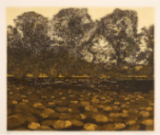
Philip Greenwood
Poolside (1973)
Etching

In Poolside lily pads stretch out across dark water to a line of trees beyond. From the low perspective we can perhaps imagine the sights and sounds that would surround us at the waters’ edge.
Though seeming familiar, the scene is in fact imagined. Rather than directly reproducing a particular place, Greenwood’s etchings amalgamate different images and memories into new scenes.

Poolside exemplifies the artist’s broader practice in creating atmospheric, reflective and sometimes dream-like images inspired by green spaces.

Philip Greenwood (b. 1943) has works held across many private and public collections including the Tate and the British Council. He was appointed a Fellow of the Royal Society of Painters and Etchers in 1982.

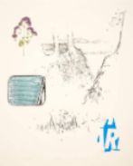
Adrian Henri
Souvenir of Normandy V (1981)
Screen-print

From the same series as Souvenir of Normandy II (above), this screenprint continues the artists’ personal reflections of a creative trip to Normandy.

In this print a tin of sardines, fragment of text and sketches of natural landscapes are composed together. Their meaning is unknown to us, but we could imagine them as memories of time with friends - talking, eating, exploring or creating together.

Adrian Henri (1932 – 2000) was a British poet and artist born in the Wirral. He is best known as founder of the ‘poetry-rock’ group the Liverpool Scene. These screenprints were produced at the Manchester Print Workshop, which was based at the University in the 1970s-80s.

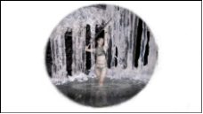
Jack Jameson
Arcadia: Queer by Nature
(2023-24)
Digital video (4m44s)

Jameson works across a variety of analogue and digital media, using poetry, craft, costume design, 3D scanning, printing and rendering, photography and animation and more. Drawing inspiration from sci-fi, mythology and folklore, this work presents a utopia where nature succeeds and ‘forest nymph, water siren and rock troll dwell in in harmony – free to be’.

Their work also reclaims the natural landscape as a place to explore identity, gender and queerness. Presenting ‘unworldly narratives of the queer form’, Arcadia becomes a sanctuary: an ecosystem where characters can flourish together
in ‘imperfect harmony’.

Jack Jameson is a Manchester based interdisciplinary artist, who has previously worked across direction, production design and costume for local film projects, music videos and commercial designs. They graduated from the BA (Hons) Media & Performance in 2020/21 and took part in the Art Collection’s Graduate Scholarship programme.


Laura Daly
The Storm Cone (2021)
3D printed model; and augmented reality app

The Storm Cone is an immersive artwork by artist Laura Daly, with music composed by Lucy Pankhurst, revealing lost bandstands in our municipal parks and exploring their forgotten histories.

Combining music and sound with augmented reality, the project considers our relationship with the past and the decline of brass bands in the interwar years. Geo-located on sites of former bandstands, the augmented reality app reveals a digital 'ghost’ of the structure along with an immersive brass band ensemble performance.

This 3D printed model uses data from the project to reproduce the Peel Park bandstand. Scan the QR code above or find The Storm Cone in the app store, and experience the full work in Peel Park.

Daly is an award-winning artist who creates works across sound, drawing, mapping, video, material objects, and immersive experiences, ‘fusing together history, memory, myth and story’. She has exhibited across the UK and internationally. The Storm Cone premiered in Peel Park in 2021 and has since toured to Southend-on-Sea, Blackpool, and Portsmouth.

The Storm Cone was commissioned through a partnership between University of Salford Art Collection and Metal in collaboration with Salford Culture and Place Partnership on the occasion of Rediscovering Salford. Generously supported using public funding by the National Lottery through Arts Council England, additionally supported by PN Daly Ltd and Zinc and Copper Roofing.

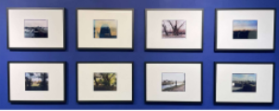
Liam Ratcliffe
In My Own Strange’ Way
(2025 – 26)
Photographic prints

Spanning a full year, photographic series In My Own Strange’ Way captures Peel Park through the changing seasons and from multiple vantage points.

The eight images presented here are selected from a larger body of ongoing work. Each image was taken either within the park or locations overlooking it, ranging from the New Adelphi Building to the River Irwell’s edge. As the seasons shift so too does the experience of the park, from the Summer bloom creating a sense of seclusion, to the transformation of colour in Autumn from green to a palette of red, yellow, and gold. The series also captures the ever-changing Manchester skyline behind the park, highlighting the relationship with nature and the evolving urban environment.

Photographed on a 10x8 camera and handprinted in the darkroom, the work embraces a slower and more intentional process of image-making, urging a sense of deep reflection on place and time. The series calls for us to pause, slow down and engage more closely with the green spaces in our everyday lives.

Liam Ratcliffe is a photographer currently based in Glossop. His traditional photographic based practice focuses on subjects such as family, local landscape and general day to day activities. He works as a Technical Assistant in the Digital Print Studio at the University of Salford.

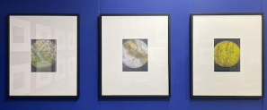
Alyssa Fort
Micro and calls (2026)
Microscopic photography

These three images are part of an urban wildlife live brief by current BA Photography student Alyssa Fort, through which the artist seeks to better understand, value, and preserve biodiversity on our campus’ green spaces.

Using a mobile phone camera and a pocket microscope, Fort captures leaves, daffodils and mushrooms in intimate detail. She later develops the compositions further by overlaying visuals from sound recordings of birdsong. Selected from local areas such as the David Lewis Playing Fields, Community Grow Garden, and Strawberry Hill, the everyday natural items appear as something from an extraterrestrial world, at once both familiar and strange.

