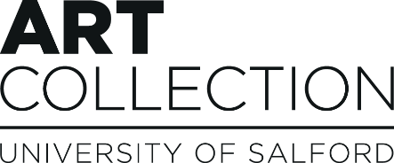
Creating / Collecting / Collaborating
Application form for University of Salford Art Collection and School of Arts, Media and Creative Technology Graduate Scholarship Programme 2023/24

Name:
Address:
Email:
Mobile:
Website:
Do you require a visa, or have a visa, that allows you to stay in the UK after graduation?
- I do not require a visa
- I do require a visa. Please state type of visa and expiry date

Do you wish to be considered for (you can select both):

Print Scholarship at Hot Bed Press Yes No
Open Scholarship Yes No
MA Scholarship Yes No

Course of undergraduate or post graduate study:
Name and email of Programme Leader
Briefly describe your creative practice (maximum 300 words).

The aim of this programme is to help develop your artistic practice and career.

Please can you tell us what you might want to develop through the programme and how might this help your future career? (maximum 500 words)

If successful, how might you use the cash award of up to £1000?
(maximum 250 words)
How would you expect to use a studio space? (If required)

If not already stated, are there any other resources or areas of support that you would feel would be beneficial if you were to be chosen for the development programme?
(maximum 250 words)

Note: A two-page CV and up to four separate examples of your work need to accompany this application form.

- Label images and video/sound files with your name, title(s) of work, description, medium and year of production.

Applications (including CV and images and/or video/sound files) should be emailed to:
R.T.Pritchard@salford.ac.uk with the subject line GSP Application Form 2023
Deadline: 9am Tuesday 9th May 2023
For any enquires contact artcollection@salford.ac.uk

Information and data submitted on these forms will be used to shortlist applicants for the Graduate Scholarship Programme and as such will be processed and stored by the University of Salford Art Collection Team. Application forms will also be shared with Castlefield Gallery for shortlisting purposes.
Application forms of shortlisted candidates will be shared with our Scholarship partners for the interview process.

Accessibility:
We are committed to equal opportunities and will work with the selected graduates to support accessibility requirements or reasonable adjustments during the programme. Access needs or appropriate support will be discussed after interview stage.

